**Question 1:**

**Write a program that prints a simple chessboard.**

**Input format:**

**The first line contains the number of inputs T.**

**The lines after that contain a different values for size of the chessboard**

**Output format:**

**Print a chessboard of dimensions size * size. Print a Print W for white spaces and B for black spaces.**

**Input:**

**2**

**3**

**5**

**Output:**

**WBW**

**BWB**

**WBW**

**WBWBW**

**BWBWB**

**WBWBW**

**BWBWB**

**WBWBW**

**Program:**

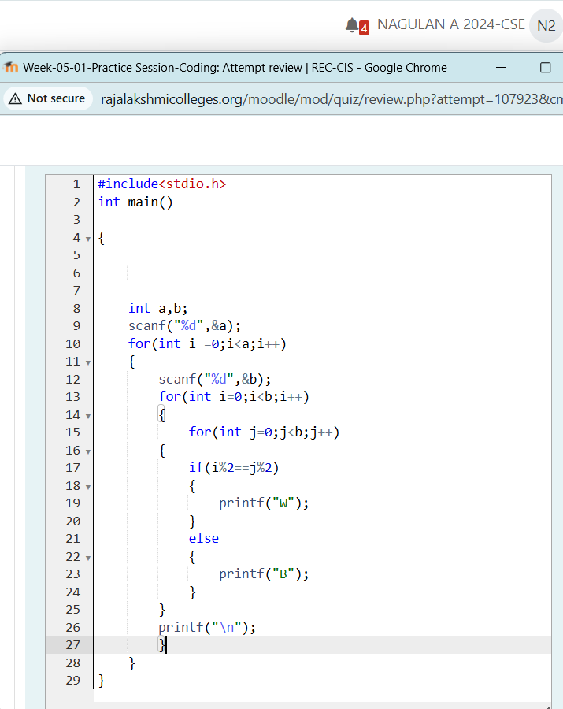

**Output:**

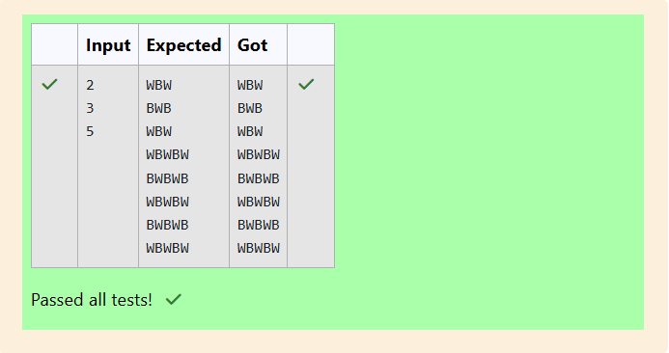

**Question 2:**

**Let’s print a chessboard!**

**Write a program that takes input:**

**The first line contains T, the number of test cases**

**Each test case contains an integer N and also the starting character of the chessboard**

**Output Format**

**Print the chessboard as per the given examples**

**Sample Input / Output**

**Input:**

**2**

**2 W**

**3 B**

**Output:**

**WB**

**BW**

**BWB**

**WBW**

**BWB**

**Program:**

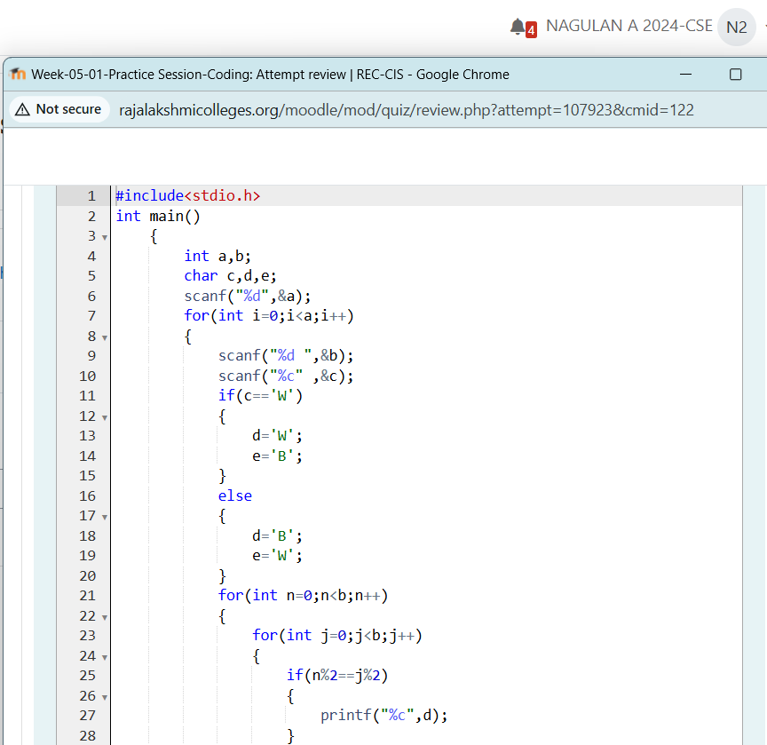

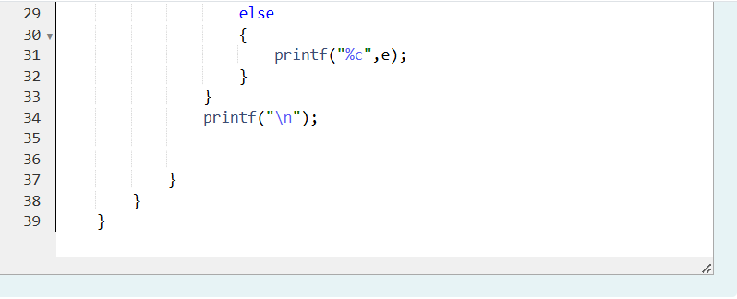

Output:

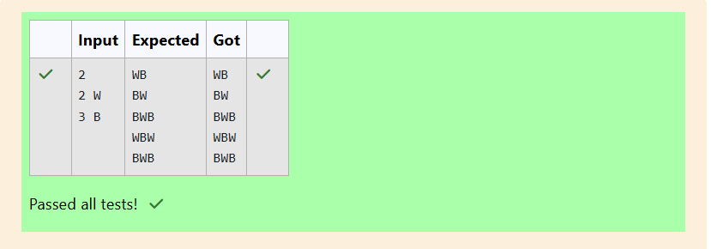

**Question 3:** **Decode the logic and print the Pattern that corresponds to given input.**

**If N= 3**

**then pattern will be :**

**10203010011012**

**\*\*4050809**

**\*\*\*\*607**

**If N= 4, then pattern will be:**

**1020304017018019020**

**\*\*50607014015016**

**\*\*\*\*809012013**

**\*\*\*\*\*\*10011**

**Input Format**

**First line contains T, the number of test cases**

**Each test case contains a single integer N**

**Output**

**First line print Case #i where i is the test case number**

**In the subsequent line, print the pattern**

**Program:**

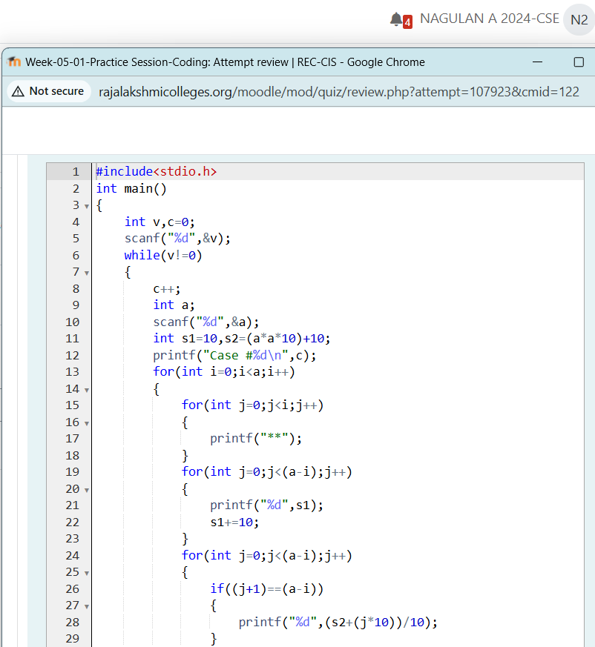

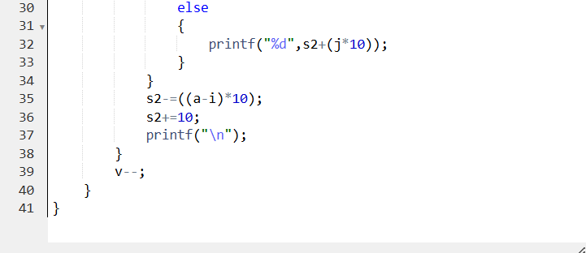

Output:

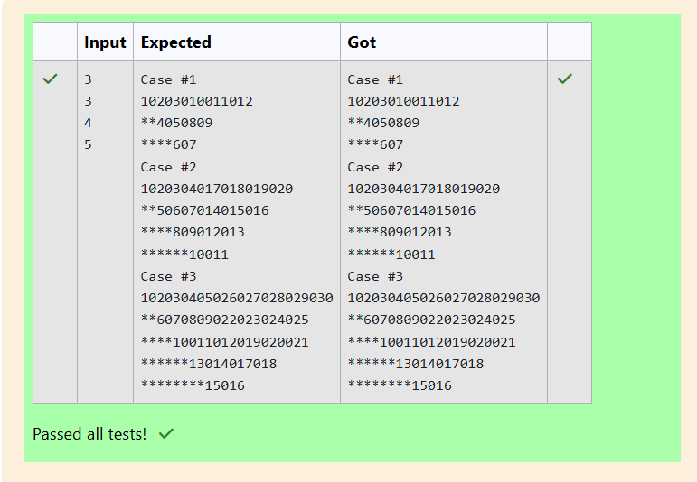

**Question 4:** **The k-digit number N is an Armstrong number if and only if the k-th power of each digit sums to N.**

**Given a positive integer N, return true if and only if it is an Armstrong number.**

**Example 1:**

**Input:**

**153**

**Output:**

**true**

**Example 2:**

**Input:**

**123**

**Output:**

**false**

**Explanation:**

**123 is a 3-digit number, and 123 != 1^3 + 2^3 + 3^3 = 36.**

**Example 3:**

**Input:**

**1634**

**Output:**

**true**

**Program:**

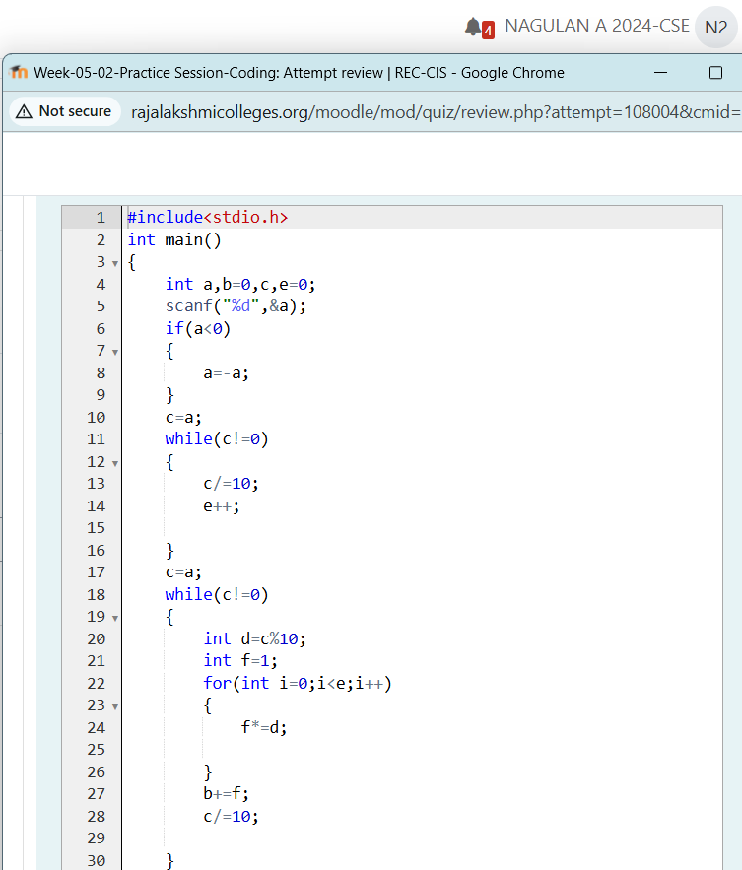

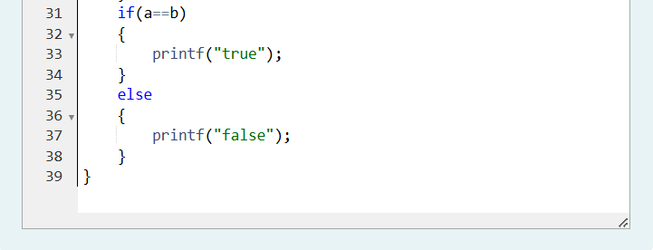

**Output:**

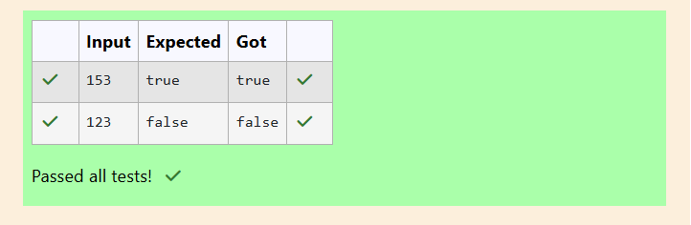

**Question 5:**

**Take a number, reverse it and add it to the original number until the obtained number is a palindrome. Constraints 1<=num<=99999999 Sample Input 1 32 Sample Output 1 55 Sample Input 2 789 Sample Output 2 66066**

**Program:** 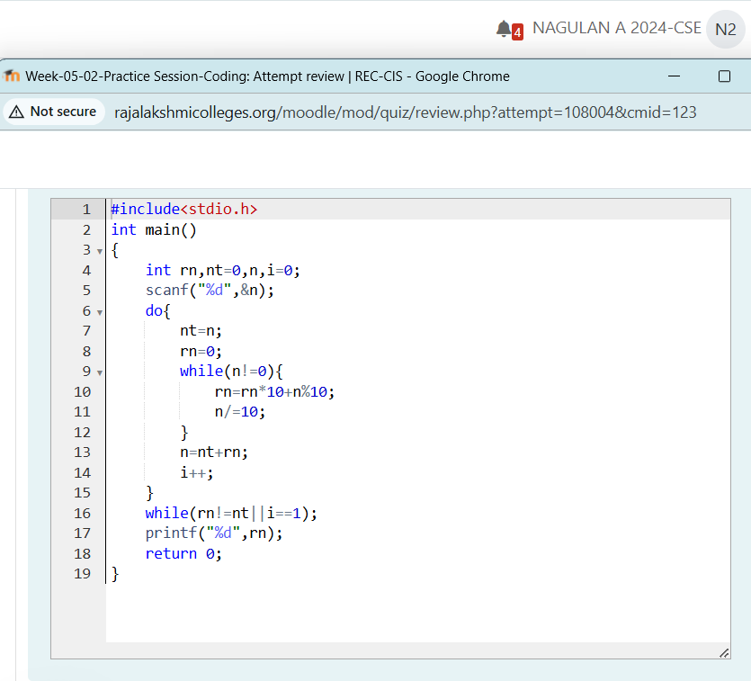

**Output**: 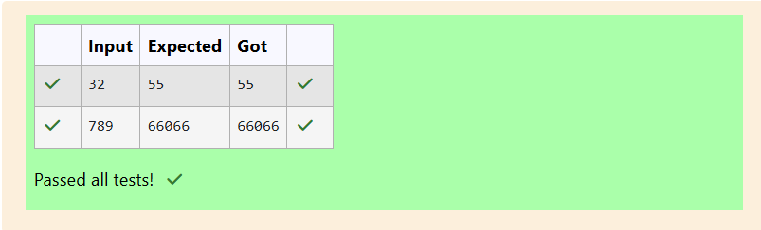

**Question 6:** **A number is considered lucky if it contains either 3 or 4 or 3 and 4 both in it. Write a program to print the nth lucky number. Example, 1st lucky number is 3, and 2nd lucky number is 4 and 3rd lucky number is 33 and 4th lucky number is 34 and so on. Note that 13, 40 etc., are not lucky as they have other numbers in it.**

**The program should accept a number 'n' as input and display the nth lucky number as output.**

**Sample Input 1:**

**3**

**Sample Output 1:**

**33**

**Program:**

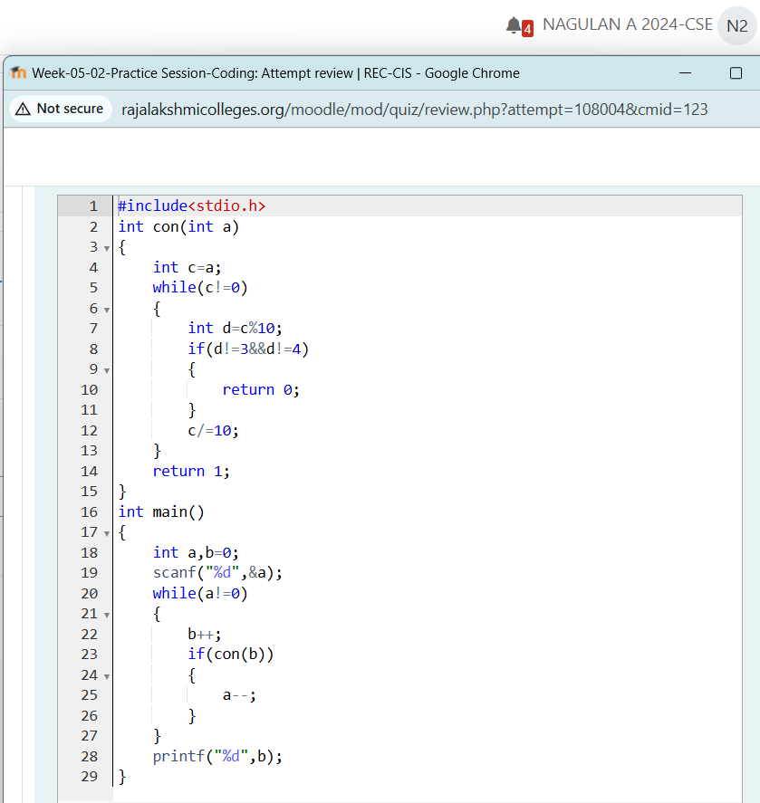

**Output:** 